Python is a general purpose high level programming language
Python was introduced by Guido van Rossum 1994

Python is developed like below
- Functional programming barrowed from C
- OOPS is barrowed from C++
- Scripting language feature from Perl and Shell script
- Modular programming feature from Module -3

Advantages of Python
Python is Free ware and Open source
Python is platform independent(can be written in any platform)
Python is portable language (Written program can be run from any platform)
No need to declare data type
Both Procedure and object oriented
Interpreted
Extensible (use other language in python)
Embedded (Python can be used in other language)
Extensive Library

Limitation:

Performance is Less
Not able to penetrate in Mobile Android

Backward compatibility is not there

Flavors of Python

CPython
Jython or JPython
Iron Python
RubyPython
AnacondaPython---to handle huge data
Stackless(Python for concurrency)

Identifier :

Name is called as identifier, it can be variable name, function name or class Name

Rules to define Identifier

Alphabet Symbols (both upper and lower case), digits (0-9), Underscores are allowed
Identifier should not start with number
Identifiers are Case Sensitive
Keywords cannot be used as identifiers
There is no length limit for identifier

If identifier starts with _ then it is private
If identifier starts with _ _ then it is strongly private
__main__ (starting and ending underscores) – language specific is identifier

Keywords in Python (there is 33 keywords)

True , False, None (Instead of Null)
and, or , not, is
if, else, elif
while , for, break, continue, return, in , yield
try, except, finally, raise, assert
import, from , as, class, def, pass, global , nonlocal, lambda, del, with

Data Types

We don’t need to define datatype explicitly

14 data types
int ---integer and long , whole numbers
float---decimal numbers
complex-----10+2j
bool
str
bytes
bytearray
range
list
tuple
set ---no duplicate value
frozenset ---no duplicate value and cannot modify
dict – key value pair
None

All the data types are objects

Inbuilt Functions

print()
type()
id()----return the address of the variable or identifier

int- Numbers without decimal numbers
int has four forms
Decimal form – base 10
a=7878 (0-9)
Binary form – Base 2
a=0b1111 (0-1)
or
a=0B1111 if we print, output is 15 (binary is converted)---(1*2^3)+(1*2^2)+(1*2^1)+(1*2^0) =8+4+2+1 =15

Octal form – Base 7
a=0o1111 (0-7)
or
a=0O1111 if we print, output is 585 (binary is converted)
HexaDecimal form – Base 16
a=0x78AbC (0-16) ---in hexa decimal r is not valid
or
a=0X78AbC if we print, output is 585 (binary is converted)

Print always in decimal form
Conversion functions
bin()
oct()
hex()

bin(15) is 1111---15 in decimal
bin(0o777) is 0b11111111
oct(786)

float- Numbers with decimal numbers
f=1234.567
float have Exponential form
f=1.2e3 ------1.2 * 10^3 = 1.2*1000 = 1200.0
print f will display 1200

complex- formation is a+bj
a=Real part
b=Imaginary part
J=sqrt(-1)

Eg - x=10+20j
Print x will print 10+20j

Y=10.5+2.5j---valid
X=0B1111+2.5j ---valid

A=10+20j
B=20+30j

A+B will print 30+50j
A-B will print -10-10j

A.real will print 10 ---to get the real part
A.imaginary print 20 - to get imaginary part

bool- Boolean value
a=True
b=False

True+True output is 2
True + False output is 1

That means True is 1 and False is 0s

str- any sequence of character
a=’chethan’ --- we can use double quote also
a=’ ’ ’chethan is “reading” ’ ’ ’
print a will print ‘chethan is “reading”’ ----second ’ acts as escape character

S = ‘chethan is reading’
S[2:8] will print ethan

Index and Slice Operator
S=’chethan’
S[0]----output is c---positive index mean left to right
S[1]----output is h
S[-1]----output is n---negative index mean right to left
S[-2]----output is a
S[2:5]----output is “eth”-----index starts from 0
S[2:]-----output is “ethan”
S[:4]----- output is “cheth”
S[-4:-1]----output is “eth”

Syntax----variable[bigin:end-1]
Variable[bein:end-1:step]

S[1:6:2] ---output is ”hta”

S*3-----output is “chethanchethanchethan”

len(S)-----gives length ---- 7

Type casting

int()
float()
complex()
bool()
str()

int(123.456)-----output is 123
int(10+20j)------not compatible
int(True)-------1
int(False)-------0
int(“10”)-----10
int(“10.5”)-----not compatible--error
int(“0B1111”) -----not compatible—error

float(10)-----output is 10.0
float (10+20j)------not compatible---error
float (True)-------1.0
float (False)-------0.0
float (“10”)-----10.0
float (“10.5”)-----10.5
float (“0B1111”) -----not compatible—error
float (“ten”) -----not compatible—error

complex(10)------10+0j
complex(10.5)-----10.5+0j
complex(True)-----1+0j
complex(False)------0j
complex(10,20)------10+20j
complex(10.5,20.5)-----10.5+20.5j
complex(“10”,”20’)--------error

bool(0)------False
bool(10)----True-----non zeros are True
bool(0.0)------False
bool(0.1)------True
bool(0+0j)-----False
bool(0+1j)------True
bool(‘cheth’)-----True, if empty string is passed then output is False(Space is also a character)

str(10+20j)------10+20j-----------pass anything to str(), it will be converted to string

Immutable-----content is Non changeable-----All the fundamental datatypes are immutable
Mutable---------content is changeable

Immutable----- x=10 then in background an object is created for 10 value and x is reference for that object
X=15 then a new object will be created for 15 and x reference will point to this new object and old object is available for garbage collection

Another concept is
X=10
Y=10
Z=10 then all these references are pointed to same object (address) because the content is same

If we do id(X) or id(Y), id(Z) then output is same

If Z=20 the new object will be created for 20 and Z will point to new object and rest will be same

Is Operator

X=10
Y=10

X is Y will return “True” because both objects are pointing to same object as content is same

X=257
Y=257

X is Y -----False ---because above concept will work till 256 only

X=10.5
Y=20.5
X is Y------False----for floating point above concept will not be applicable

X=10+20j
Y=10+20j
X is Y------False----for complex above concept will not be applicable

For all bool and str data types, above concept always works

That means for Float and complex datatypes always new object will be created

bytes data type----group of byte numbers

X=[10,20,30,40]
B=bytes(X)

B[0]-----10
B[2]-----30
B[-1]----40

for x in B : print (x)

prints
10
20
30
40

Bytes range is 0-256 only

That means
X=[10,20,257,258]
B=bytes(X) -------error, values should be less than 256

Bytes is immutable
B[0]--------10
B[1]=50 -------------gives error because is assignment is not allowed

byteArray data type----group of byte numbers (only diff is it is mutable)

X=[10,120,30,40]
B=bytearray(X)
Type(B)------bytearray

B[1]=120------allowed

For X in B: print(X)

Prints
10
120
30
40

list Data Type----represent group of values as single entity where insertion order is preserved and duplicates are allowed

l=[]
type(l)-------list

l.append(10)
l.append(20)
l.append(10)

print(l)--------[10, 20, 10]

l.append(‘chethan’)----allowed

print(l)--------[10, 20, 10, ‘chethan’]

l.append(None)

l[0]-------10
l[-1]-------Nothing------------ because last object is None

l[1:3]-----[20, 10]

l.remove(10) ------first 10 will be removed
l.clear()
l.count(value)---for ex l.count(10)-----prints how many 10 are there in list
l.index(20)---prints the index of value
l.reverse()
l.copy()--------m=l.copy-----list will be copied to new list
l.pop(number)----if number is not provided the by default last number will be removed, if number is provided then last number of digits will be removed

-order is preserved
-duplicated are allowed
-growable or reducible
-allows heterogeneous data types

list.append(elmnt)----- method appends an element to the end of the list.
list.clear() ----- method removes all the elements from a list.
list.copy()------method returns a copy of the specified list.
list.count(value)------ method returns the number of elements with the specified value.
list.extend(iterable)---- method adds the specified list elements (or any iterable) to the end of the current list.

fruits = ['apple', 'banana', 'cherry']
cars = ['Ford', 'BMW', 'Volvo']
fruits.extend(cars)----- ['apple', 'banana', 'cherry', 'Ford', 'BMW', 'Volvo']

list.index(elmnt)---- method returns the position at the first occurrence of the specified value. Exception if element is not found
list.insert(pos, elmnt)----- method inserts the specified value at the specified position.
list.pop(pos)------ method removes the element at the specified position.
list.remove(elmnt)------ method removes the first occurrence of the element with the specified value.
list.reverse()-----method reverses the sorting order of the elements.
list.sort(reverse=True|False, key=myFunc)----- method sorts the list ascending by default.

cars = ['Ford', 'BMW', 'Volvo']
cars.sort()
print(cars)------- ['BMW', 'Ford', 'Volvo']

we can compare lists like x==y where both x and y are list objects. To get true
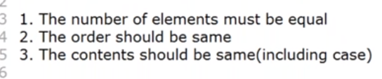
x<y, X<=Y------all works each element from both objects will be compare

x=[[10,20,30],[40,50,60],[70,80,90]]---------possible like 2D array
x[0]----[10,20,30]
x[0,0]-----10

List Comprehension
L1=[x*x for x in range(1,5)]
Output------[1,4,9,16,25]

L2=[x for x in l1 if x%2=0]
Output---[4, 16]

Syntax : list variable = [expression for x in sequence if condition]

tuple data type

only difference between list and tuple is list is mutable and tuple is immutable

t=(10,20,’chethan’,True)

list is defined like l=[10,20,’chethan’,True]

t[0]------10
t[1]=30-------------gives error because tuple is immutable

t1=t*2------works new tuple created adding the elements two times

print t1 would be(10,20,’chethan’,True, 10,20,’chethan’,True)

t2=(10,20,[2,3])----this is valid-----third element is list object

tuple.count(value)-------- method returns the number of times a specified value appears in the tuple.
tuple.index(value)------- method finds the first occurrence of the specified value. method raises an exception if the value is not found.
New tuple = sorted(tuple)
T1=(10,20,30,40)
T2=tuple(sorted(T1,reverse=True))

min(T1)-----10-----will work only for homogeneous elements only
max(T1)-----40

T1<T2, T1>T2------works

Tuple packing
A=10
B=20
C=30
T=A,B,C
Print(T)------(10,20,30)

Unpacking
A,B,C=T

unpacking is applicable to List , set and string as well

tuple can be used as keys of dictionary object where as list cannot be used

range data type

it represent sequence of values , it is immutable

r=range(10)

print r will print “range(0,10)”

for I in r : print (i) ---prints
0
1
2
.
.
.
.
9

r[2] = 777----error because range doesn’t support item assignment

--Second way
r=range(10,30)----it represent the number from 10-29

--Third way
r=range(10, 50 ,5)----it represent the number from 10-49 step is 5

for I in range (10,50, 5) : print (i)

it will print 10,15,20,25,30,35,40,45

---range (10.5, 20.6)-----gives error

set data type -represent group of values as single entity where insertion order is not preserved and duplicates are not allowed

create empty set is s=set()
s={10,20,30}
s={10,20,30,10,20,30}-----allowed but duplicate will not be stored
if we print s, it prints only {10,20,30}
indexing and slicing is not applicable for set because order is not preserved
s[0]-----gives error
s[1:]---gives error

Set doesn’t preserve insertion order
Set doesn’t store duplicate value
Heterogeneous values can be stored
Indexing is not allowed
Slicing is not allowed
It is mutable that means we can change the values

s.add(40)
s.remove(20)
s.clear
s.differance(s2)----returns diff of two sets
s.intersection(s2)----returns common value of two sets
s.issubset(s2)----checks s2 is subset of s

set.add(elmnt)---- method adds an element to the set. If the element already exists, the add() method does not add the element.

set.clear()-----method removes all elements in a set.

set.copy()------method copies the set.

set.difference(set)---- method returns a set that contains the difference between two sets. The returned set contains items that exist only in the first set, and not in both sets.

x = {"apple", "banana", "cherry"}
y = {"google", "microsoft", "apple"}
z = x.difference(y)
print(z)----------------------------------- {'cherry', 'banana'}

set.difference_update(set)-----difference() method returns a new set, without the unwanted items, and the difference_update() method removes the unwanted items from the original set.

set.discard(value)----- method removes the specified item from the set. method will not raise an error if the specified item does not exist

set.intersection(set1, set2 ... etc)-------- method returns a set that contains the similarity between two or more sets.

set.intersection_update(set1, set2 ... etc)---- method removes the unwanted items from the original set

set.isdisjoint(set)------ method returns True if none of the items are present in both sets, otherwise it returns False.

set.issubset(set)------ method returns True if all items in the set exists in the specified set, otherwise it retuns False.

set.issuperset(set)----- method returns True if all items in the specified set exists in the original set, otherwise it retuns False.

set.pop()---method removes a random item from the set.

set.remove(item)---- method removes the specified element from the set. method will raise an error if the specified item does not exist

set.union(set1, set2...)---- method returns a set that contains all items from the original set, and all items from the specified sets.

set.update(set)------- method updates the current set, by adding items from another set.s

s.update(set variable name, range(1,10),’chethan’)------everything gets added, this doesn’t apply for add()
update doesn’t take single value, it should be sequence of values as one element, and these elements can be multiple

list can be converted to set
s=set(list variable name)
s=set(range(1,9))-----works

create empty set
s=set()
s={}----creates dictionary not set

just like list comprehension , set comprehension also present, refer list comprehension above

frozenset data type -It is same as set but it is immutable

s={10,20,30}
fs=frozenset(s)

fs.add(40)-----gives error
fs.remove(20)-----gives error

dict data type -It represent key value pair

key cannot be duplicate value, value can be duplicate
keys and values can be heterogeneous
dictionary is mutable means values can be added and modified

empty dictionary d1={}
d={10 : ’chethan’, 20 : ‘Deepika’ , 30 : ‘Tilak’}
to add later
d[40]=’Lakshman’----added new one
d[10]=’Dasaiah’----chethan will be replaced with new value

to get item
d[10]-------Dasaiah

dictionary.clear()------method removes all the elements from a dictionary.

dictionary.copy()----method returns a copy of the specified dictionary.

dict.fromkeys(keys, value)------ method returns a dictionary with the specified keys and values.

x = ('key1', 'key2', 'key3')
y = 0
thisdict = dict.fromkeys(x, y)----- ['key1': 0, 'key2': 0, 'key3': 0]
print(thisdict)

dictionary.get(keyname, value)---- method returns the value of the item with the specified key.

dictionary.items()---------method returns a view object. Returns list of tuples

car = {
"brand": "Ford",
"model": "Mustang",
"year": 1964
}
x = car.items()
print(x)------ dict_items([('brand', 'Ford'), ('model', 'Mustang'), ('year', 1964)])

for k, v in car.items()
print (k , ‘……’ , v)

dictionary.keys()------ method returns a view object. The view object contains the keys of the dictionary, as a list.

dictionary.values()------method returns a view object. The view object contains the values of the dictionary, as a list.

dictionary.pop(keyname, defaultvalue)----- method removes the specified item from the dictionary.

dictionary.popitem()-----------method removes the item that was last inserted into the dictionary.

dictionary.update(iterable)-------- method inserts the specified items to the dictionary.
car.update({"color": "White"})

dictionary.setdefault(key, value) -----if key is already available , don’t do anything. If not available add new key value

to update dictionary object
d[100]=’chethan’

to delete

del d[100]----if entry exist then it will delete both key and value , if not then gives error

del d------------remove complete dictionary

len (d) ----number of elements /keys
value for a key can be list

ways to create dictionary object
d={}
d=dict()
d=dict({10:’chethan’, 20 : ‘Deepika’}}
d={10:’chethan’, 20 : ‘Deepika’}
d=dict( [ ( 10,’chethan’) , (20, ‘Deepika’) ] )-----list/tuple/set of tuple values can form dictionary object
output : {10 : ‘chethan’ , 20 : ’Deepika’}

None Data type-----If function doesn’t return anything
Pass-----if function doesn’t have proper implementation then we can use pass in function just to avoid error when function is called

Def f1() :

If f1 is called there will be error because there is nothing written in function to avoid this write pass in function

Escape characters

S= ‘chethan\nstudying’
Print(s) ----prints
Chethan
Studying-----in new line

\t-----ads tab
\r
\b--- backspace
\f------next page
\’ ----adds single quote
\”----adds double quote
\\
\v-----vertical tab

Using of double quote in string

S=”Chethan \“is\” studying” -----using of backslash
Or
S=’Chethan “is” studying’-----write in single quote
S=”Chethan ‘is’ studying”-----write in single quote

S=’’’chethan ‘is’ studying “in” room’’’ or use escape character

Constants

There is no keyword to specify constant in python

We can declared with CAPITAL letters variable name for our understand to assume it as constant like MAX_VALUE

String data Type

String is sequence of characters
There is no char data type in python
Ch=’a’ ----is also considered as string
If we want to define multi line string value then use triple (single or double) quote

Ch =’’’chethan
Studying
Python’’’
Print (ch)

Output:
Chethan
Studying
Python

S1=’’’This is ‘ and “ quote symbols’’’------use single and double quotes as symbols in string
S1=”this is ‘ quote symbols”-----works single quote will be considered as symbol
S1=’this is “ quote symbols’-----works double quote will be considered as symbol
S1=’this is ‘ quote symbols’-----doesn’t work, single quote will considered as end of string
S1=’this is \‘ quote symbols’-----works single quote will be considered as symbol

Accessing characters of string
S=’Chethan’
S[0]------C
S[1]------h
S[-1]-----n
S[-2]-----a
S[0:3]-----Chet
S[-3:-1]----han
S[0:6:2]---Ceh-----step increment is 2
S[1:-2:2]---hta, step is +ve then forward direction, -ve means backward direction

To reverse string
S[::-1]-----nahtehC ----step is -1 hence reverse printing will happen

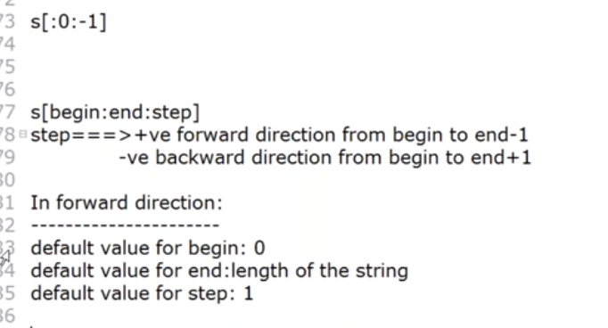
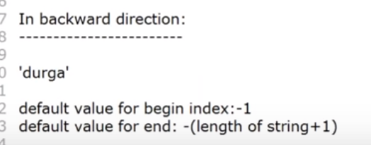

string.capitalize()----method returns a string where the first character is upper case.
string.casefold()------method returns a string where all the characters are lower case.
string.count(value, start, end) -----method returns the number of times a specified value appears in the string.
string.endswith(value, start, end)----- method returns True if the string ends with the specified value, otherwise False
string.find(value, start, end)------ method finds the first occurrence of the specified value.
string.index(value, start, end)-------method finds the position of first occurrence of the specified value. method raises an exception if the value is not found.

To solve exception problem
s='chethan is studying'
input =input('enter the string : ')
if input in s: ----first check the string is present or not
print ("target is present at ", s.index(input))
else:
print("target is not present")

or

s='chethan is studying'
input =input('enter the string : ')
try:
print ("target is present at ", s.index(input))
except:
print("target is not present")

string.isalnum()-----method returns True if all the characters are alphanumeric, meaning alphabet letter (a-z) and numbers (0-9).
string.isdigit()----method returns True if all the characters are digits, otherwise False.
string.islower()----method returns True if all the characters are in lower case, otherwise False.
string.isupper()----method returns True if all the characters are in upper case, otherwise False.
string.isnumeric()----method returns True if all the characters are numeric (0-9), otherwise False.
string.isalpha()-----checks string is alphabit
string.join(iterable)----method takes all items in an iterable and joins them into one string.

myTuple = ("John", "Peter", "Vicky")
x = "#".join(myTuple)
string.lower()----method returns a string where all characters are lower case.
string.upper()-----method returns a string where all characters are in upper case.
string.replace(oldvalue, newvalue, count)---- method replaces a specified phrase with another specified phrase.
string.rfind(value, start, end)---- method finds the last occurrence of the specified value.
string.rindex(value, start, end)------ method finds the last occurrence of the specified value.
string.rsplit(separator, max)---- method splits a string into a list, starting from the right.
string.split(separator, max)----- method splits a string into a list.
string.startswith(value, start, end)-----method returns True if the string starts with the specified value, otherwise False.
string.title()-----method returns a string where the first character in every word is upper case..

s=’chethan’
sorted(s)----returns list with sorted string character

program to sort the string
s='chethan'
output=''
for i in sorted(s):
output=output+i
print(output)

acehhnt

Sum of dictionary values

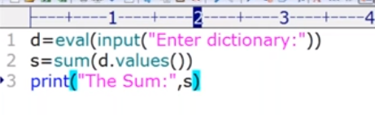

Sum function works for list, set and tuple as well

-Number of times specific letter repeated

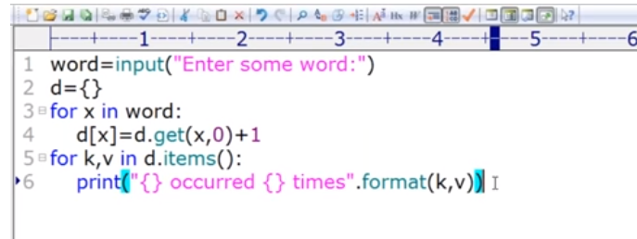

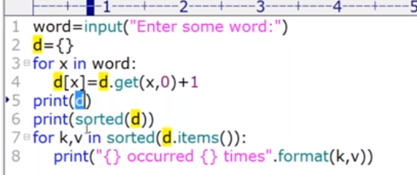
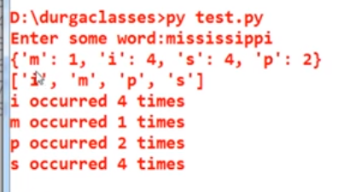

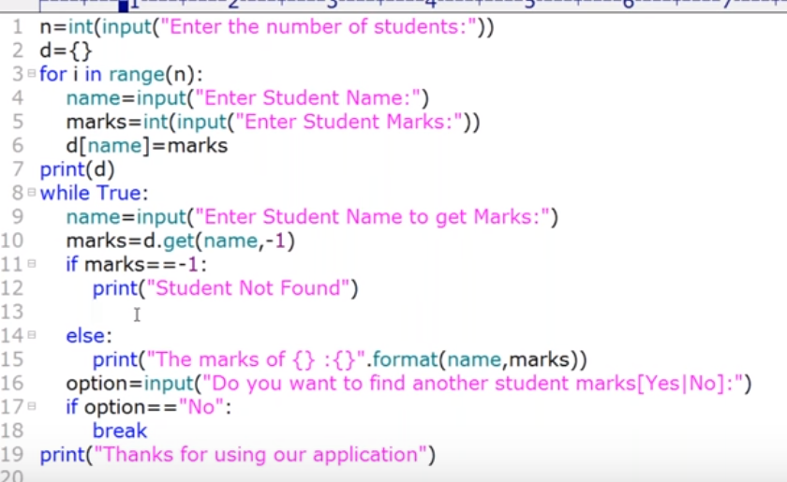

Comprehension for dictionary

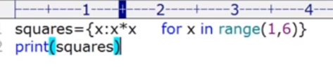

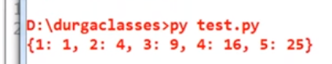

31-01-2018 - Done

